Intelligent customer help desk with smart document understanding

Name: Reshma M

College: Sri venkateshwara college of engineering

Internship at Smartbridge

1.Introduction

A chatbot is an artificial intelligence [(AI) software that can simulate a conversation](https://expertsystem.com/learning-center/technology/) (or a chat) with a user in natural language through messaging applications, websites, mobile apps or through the telephone.  
Why are chatbots important? A chatbot is often described as one of the most advanced and promising expressions of interaction between humans and machines. However, from a technological point of view, a chatbot only represents the natural evolution of a Question Answering system leveraging Natural Language Processing (NLP). Formulating responses to questions in natural language is one of the most typical Examples of Natural Language Processing applied in various enterprises’ end-use applications.

Overveiw:

Creating chatbot which can answer simple questions , such as store locations ,

directions and maybe even making even appointments.

Learning Watson Discovery Science

* Create a customer care dialog skill in Watson AssistantUse Smart Document Understanding to build an enhanced Watson Discovery collection
* Create an IBM Cloud Functions web action that allows Watson Assistant to post queries to Watson Discovery
* Build a web application with integration to all these services & deploy the same on IBM Cloud Platform.

Purpose:

In fact, over 59% of millennials and 60% of Gen Xers in the United States have [interacted with chatbots](http://www.businessinsider.com/chatbot-monetization-market-business-strategies-opportunites-2017-11).

And according to a [Facebook survey,](https://messenger.fb.com/) more than 50% of customers say they’re more likely to shop with a business that they can connect with via chat.

According to [Gartner](https://www.gartner.com/imagesrv/summits/docs/na/customer-360/C360_2011_brochure_FINAL.pdf#page=2),

“By 2020, 85% of our engagement with businesses will be done without interacting with another human. Instead, we’ll be using self-service options and chatbots.”

Additionally, according to an [Oracle survey](http://businessinsider.com/80-of-businesses-want-chatbots-by-2020-2016-12),

“80% of businesses said they currently use or are planning to use chatbots by 2020.”

Customers expect to be able to find the information they’re looking for in a click of a button and in the blink of an eye.

When this isn’t possible, frustration brews, and this can lead to you losing a sale or even [losing a potential customer forever](https://www.bigcommerce.com/ecommerce-answers/what-customer-attrition/).

To understand how chatbots can mitigate some of these frustrations and improve the user experience, we need to first look at how customers are choosing to interact with businesses today.

In the 2017 Global State of Customer Service Report by Microsoft, we can see how email and telephone are still the dominant communication channels for many customers.

Literature Survey:

**1.Existing Problem:**

The typical customer care chatbot can answer simple questions, such as store locations and hours, directions, and maybe even making appointments. When a question falls outside of the scope of the pre-determined question set, the option is typically to tell the customer the question isn’t valid or offer to speak to a real person.

**2.Proposed Solution:**

In this project, there will be another option. If the customer question is about the operation of a device, the application shall pass the question onto Watson Discovery Service, which has been pre-loaded with the device’s owners manual. So now, instead of “Would you like to speak to a customer representative?” we can return relevant sections of the owners manual to help solve our customers’ problems.

To take it a step further, the project shall use the Smart Document Understanding feature of Watson Discovery to train it on what text in the owners manual is important and what is not. This will improve the answers returned from the queries.

Theoretical Analysis:

**1.Block Diagram:**

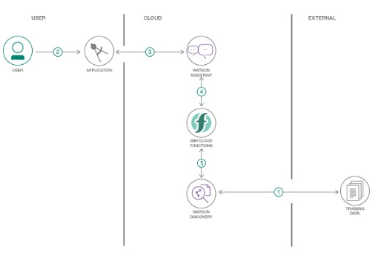

Software Designing:

1.Watson Assistant:

**Watson** **Assistant** customer service demo This Node.js app is a fully developed example of the type of app you can build with **Watson** **Assistant** that uses intents, entities, and dialog.

Use IBM Watson™ Assistant to build your own branded live chatbot into any device, application, or channel. Your chatbot, which is also known as an *assistant*, connects to the customer engagement resources you already use to deliver an engaging, unified problem-solving experience to your customers.

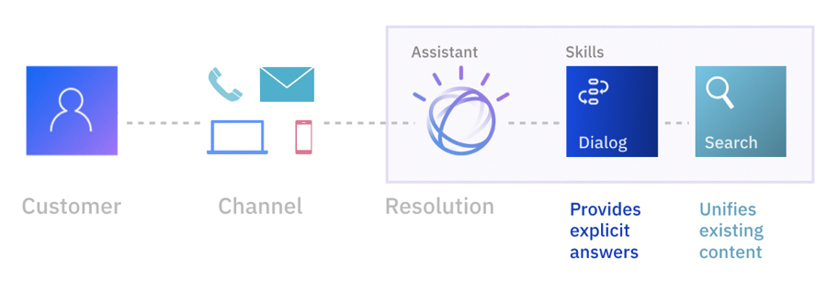

* Users interact with the assistant through one or more of these **integration** points:
  + A virtual assistant that you publish directly to an existing social media messaging platform, such as Slack or Facebook Messenger.
  + A custom application that you develop, such as a mobile app or a robot with a voice interface.
* The **assistant** receives user input and routes it to the dialog skill.
* The **dialog skill** interprets the user input further, then directs the flow of the conversation. The dialog gathers any information it needs to respond or perform a transaction on the user's behalf.
* Any questions that cannot be answered by the dialog skill are sent to the **search skill**, which finds relevant answers by searching the company knowledge bases that you configure for the purpose.
* **Intents**: Goals that you anticipate your users have when they interact with your assistant. Define one intent for each goal that can be identified in a user's input. For example, you might define an intent that is named *store_hours* that answers questions about store hours. For each intent, you add sample utterances that reflect the input customers might use to ask for the information they need, such as, What time do you open?
* Or use prebuilt **content catalogs** that are provided by IBM to get started with data that addresses common customer goals.
* **Dialog**: Use the dialog editor to build a dialog flow that incorporates your intents. The dialog flow is represented graphically as a tree. You can add a branch to process each of the intents that you want your assistant to handle.
* **Entities**: An entity represents a term or object that provides context for an intent. For example, an entity might be a city name that helps your dialog to distinguish which store the user wants to know store hours for. After you add entities, update your dialog to use them. Add dialog nodes that handle the many possible permutations of a request based on the entities that are found in the user input.
* As you add training data, a natural language classifier is automatically added to the skill. The classifier model is trained to understand the types of requests that you teach your assistant to listen for and respond to.
* Add a search skill.
* Take advantage of data collections that you create in IBM Watson™ Discovery to provide answers to customer questions. When a customer asks a question that the dialog is not designed to answer, your assistant can search for relevant information from the configured data sources, extract the information, and return it as the assistant's response.

2.Watson Discovery:

The IBM Watson™ Assistant Discovery Extension for IBM Cloud Private service offers powerful content search capabilities. After your content is uploaded and enriched by the Watson Assistant Discovery Extension service, you can build queries, then integrate Watson Assistant Discovery Extension into your own projects.

When you create a query or filter, Watson Assistant Discovery Extension looks at each result and tries to match the paths you have defined. When matches occur, they are added to the results set. When creating a query, you can be as vague or as specific as you want. The more specific the query, the more targeted the results.

Start out by getting to know the Watson Assistant Discovery Extension JSON. To understand how to build a query using the Discovery Query Language, you need to be familiar with the JSON produced by Watson Assistant Discovery Extension after it enriches the documents in your collection. Once you are familiar with the data schema of your documents, it will be easier to write queries in the Discovery Query Language. There are three ways to do this.

1. In the Watson Assistant Discovery Extension Tooling, open the **Manage data** screen, choose the collection that contains the IBM Press Releases. Click the **View Data Schema** button. The **View data schema** screen displays the fields and values in your transformed documents two ways: by document (**Document view**), or by field (**Collection view**). A maximum of 50 documents displays in **Document view**. **Collection view** displays the fields in the entire collection.
2. In the **Collection view**, under enriched_text, you can examine the enrichments you applied with the **Default Configuration** file. Click on keywords to see how your collection was enriched with Watson insights.
3. Run an "empty" query to view the JSON. On the **View data schema** screen, click the **Build queries** button, then click **Run Query**. The results display on the right, under two tabs, **Summary** (an overview of the query results) and **JSON**. Start by opening the **JSON** tab.
   * Each of the four documents is proceeded by an id number.
   * Scroll down to the enriched_text field. Examine each enrichment to learn about the JSON fields you can query on.
   * **keywords** - Start by finding the text field, and examine the other enrichment information.
4. After you have examined the insights in the first document, you can look at the other three documents if you like.
5. View the available fields in the **Visual Query Builder**. On the **Build queries** screen, click **Search for documents**, then **Use the Discovery Query Language**. Click the **Field** drop-down to view the fields available in your data. Click **Edit in query language** to build queries manually by using the Discovery Query Language.

3.Cloud Functions:

With IBM Cloud™ Functions you can use your favorite programming language to write lightweight code that runs app logic in a scalable way. You can run code on-demand with HTTP-based API requests from applications or run code in response to IBM Cloud services and third-party events. The Function-as-a-Service (Faas) programming platform is based on the open source project Apache OpenWhisk.

With IBM Cloud™ Functions, you can create stateless code snippets, called actions, that are set to perform one specific task. To learn more about actions and other Functions terms

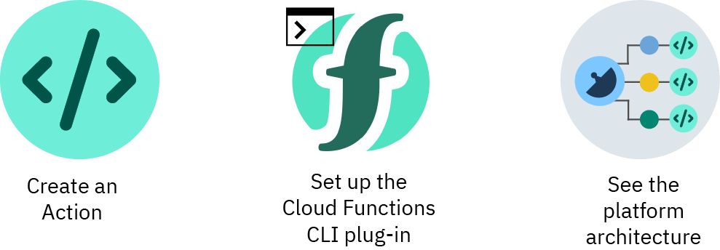

FaaS (Function-as-a-Service) is a type of [cloud-computing](https://www.ibm.com/cloud/learn/cloud-computing) service that allows you to execute code in response to events without the complex infrastructure typically associated with building and launching [microservices](https://www.ibm.com/cloud/learn/microservices) applications.

Hosting a software application on the internet typically requires provisioning and managing a virtual or physical server and managing an operating system and web server hosting processes. With FaaS, the physical hardware, virtual machine operating system, and web server software management are all handled automatically by your cloud service provider. This allows you to focus solely on individual functions in your application code.

## FaaS vs Serverless

Serverless and Functions-as-a-Service (FaaS) are often conflated with one another but the truth is that FaaS is actually a subset of serverless. Serverless is focused on any service category, be it compute, storage, database, messaging, api gateways, etc. where configuration, management, and billing of servers are invisible to the end user. FaaS, on the other hand, while perhaps the most central technology in serverless architectures, is focused on the event-driven computing paradigm wherein application code, or containers, only run in response to events or requests.

4.Node-Red App:

**Node-RED** is a [flow-based](https://en.wikipedia.org/wiki/Flow-based_programming) development tool for [visual programming](https://en.wikipedia.org/wiki/Visual_programming_language) developed originally by [IBM](https://en.wikipedia.org/wiki/IBM) for wiring together hardware devices, [APIs](https://en.wikipedia.org/wiki/Application_programming_interface) and [online services](https://en.wikipedia.org/wiki/Online_services) as part of the [Internet of Things](https://en.wikipedia.org/wiki/Internet_of_Things).[[2]](https://en.wikipedia.org/wiki/Node-RED#cite_note-2)

Node-RED provides a [web browser](https://en.wikipedia.org/wiki/Web_browser)-based flow editor, which can be used to create [JavaScript](https://en.wikipedia.org/wiki/JavaScript) functions. Elements of applications can be saved or shared for re-use. The runtime is built on [Node.js](https://en.wikipedia.org/wiki/Node.js). The flows created in Node-RED are stored using [JSON](https://en.wikipedia.org/wiki/JSON). Since version 0.14, [MQTT](https://en.wikipedia.org/wiki/MQTT) nodes can make properly configured [TLS](https://en.wikipedia.org/wiki/Transport_Layer_Security) connections.[[3]](https://en.wikipedia.org/wiki/Node-RED#cite_note-3)

Node-RED is a programming tool for wiring together hardware devices, APIs and online services in new and interesting ways.

It provides a browser-based editor that makes it easy to wire together flows using the wide range of nodes in the palette that can be deployed to its runtime in a single-click.

Result:

<https://node-red-resh.eu-gb.mybluemix.net/ui/#!/0?socketid=lwaZYIAvT2WI9k3-AAAG>

Advantages and Disadvantages:

## ADVANTAGES OF CHATBOTS

Humans can serve a limited number of clients at the same time. This restriction does not exist for chatbots, and they can manage all necessary queries simultaneously.

Their main advantages are:

* **Reduced costs:** Chatbots eliminate the need for labor during online interaction with customers. This is obviously a great advantage for companies that receive multiple queries at once. In addition to saving costs with them, companies can align the chatbot with their objectives, and use them as a means to enhance customer conversion.
* **24/7 Availability:** Unlike humans, once we install a chatbot, it can handle queries at any time of day. Thus, the customer does not have to wait for a commercial of the company to help him. This also allows companies to monitor customer « traffic » during non-working hours and contact them later.
* **Learning and updating:** AI-based chatbots are able to learn from interactions and update independently. This is one of the main advantages. When you hire a new employee, you have to train them continuously. However, chatbots « form » themselves (with certain limitations, of course).
* **Management of multiple clients:** Humans can serve a limited number of customers at the same time. This restriction does not exist for chatbots, and they can manage all the necessary queries simultaneously. This is one of the main advantages of using chatbot, as no customer is left unattended and you are solving different problems at the same time. There are chatbots companies already working on developing voice chatbot services.

## DISADVANTAGES OF CHATBOTS

* **Complex interface:** It is often considered that chatbots are complicated and need a lot of time to understand what you want in customer. Sometimes, it can also annoy the client about their slowness, or their difficulty in filtering responses.
* **They don’t get you right:** Fixed chatbots can get stuck easily. If a query doesn’t relate to something you’ve previously « taught » it, you won’t understand it. This can lead to a frustrated customer and the loss of the sale. Other times they do understand you, but they need double (or triple) as many messages as one person, which spoils the user experience.
* **Time-consuming:** Chatbots are installed with the aim of speeding up responses and improving customer interaction. However, due to the limited availability of data and the time needed for self-updating, this process can be slow and costly. Therefore, there are times when instead of serving several customers at once, chatbots may become confused and not serve the customer well.
* **Installation cost:** Chatbots are useful programs that help you save a lot of labor by ensuring availability at all times and serving several customers at once. But unlike humans, each chatbot needs to be programmed differently for each business, which increases the initial installation cost. Considering the last-minute changes that can always occur, this is a risky investment, as updating the program will generate additional costs.
* **Null decision making:** Chatbots can attack the nerves of more than one because they are not able to make decisions.

Applications:

Chatbots are computer programs that interact with users using natural languages. This technology started in the 1960’s; the aim was to see if chatbot systems could fool users that they were real humans. However, chatbot systems are not only built to mimic human conversation, and entertain users. In this paper, we investigate other applications where chatbots could be useful such as education, information retrival, business, and e-commerce. A range of chatbots with useful applications, including several based on the ALICE/AIML architecture, are presented in this paper. Chatbots sind Computerprogramme, die mit Benutzern in natürlicher Sprache kommunizieren. Die ersten Programme gab es in den 60er Jahren; das Ziel war festzustellen, ob Chatbots Benutzer davon überzeugen könnten, dass sie in Wirklichkeit Menschen seien. Chatbots werden aber nicht nur gebaut, um menschliche Kommunikation nachzuahmen und um Benutzer zu unterhalten. In diesem Artikel untersuchen wir andere Anwendungen für Chatbots, zum Beispiel in Bildung, Suchmaschinen, kommerzielle Anwendungen und e-commerce. Wir stellen eine Reihe von Chatbots mit nützlichen Anwendungen vor, einschliesslich mehrerer Chatbots, die auf der ALICE/AIML Architektur basieren.

### 1.Content delivery

Media Publishers have realized that chatbots are a powerful way to engage with their audiences and monitor engagement to gain valuable insights on reader interests. Chat with the CNN and Wall Street Journal Chatbots on Facebook Messenger and receive the latest news directly in Messenger, without having to visit their websites.

### 2. Order Food

Various fast food giants like KFC and Pizza Hut have invested in Chatbots that enable customers to place their orders through conversations. Taco Bell went a step further to improve the conversational experience by giving their Chatbot named TacoBot some personality. It cracks jokes, uses emojis, answers trivia questions, and will even add a cup of water to an order if the customer mentions being hungover.

### 3. Book Flights

Icelandair’s chatbot gives their customers the ability to search for and book flights in a text-based conversational manner. Instead of drop-down menus, customers enter the information themselves. These features give customers more control over how the flight is booked and it also keeps the entire conversation in one thread so that the purchase information can be reviewed and called up with ease.

### 4. Companionship

Russian technology company Endurance developed its [companion chatbot](http://endurancerobots.com/azbnmaterial/a-robot-companion-for-senior-people-and-patients-with-alzheimer-s-disease/) for Senior People and Patients with Alzheimer’s Disease. The primary function of the chatbot is to be a virtual companion – To speak with senior people on general topics like the weather, nature, hobbies, movies, music, news, etc. The chatbot asks questions, reacts to the answers, is able to speak on various topics, and share interesting news and facts from Google

### 5. Market Research

The way market researchers get in touch with respondents is changing as many respondents may prefer to be contacted on WhatsApp or the Facebook messenger. Instead of having a dedicated survey app, many research firms are developing Chatbots to have personalized, engaging conversational surveys with respondents to improve the experience and increase completion rates.

Future Scope :

From gauging purchase intent to answering questions about IT issues, chatbots are on track to play a major role in the contemporary enterprise. Chatbots are fully functioning, semi-autonomous systems that can assist customer service experiences and response time.

But that doesn't mean their future in the enterprise is secure. For [chatbots](https://searchcustomerexperience.techtarget.com/definition/chatbot) to withstand the rapidly increasing technological shifts and become mainstays in the enterprise, developers need to examine the issues that have popped up with increased implementation.

The future scope of chatbots could include many benefits for enterprises, but experts say they will need to be gently nudged in the right direction for businesses to reap these benefits.

### Removing barriers to entry

Currently chatbots are growing at a rate of 24% annually, and the industry is projected to be a [$1.25 billion market](https://www.grandviewresearch.com/press-release/global-chatbot-market) by 2025, according to Grand View Research Inc. Beyond the next five years, however, the [future of chatbots](https://searchcustomerexperience.techtarget.com/news/252478598/Googles-Meena-AI-chatbot-to-eventually-find-its-way-into-CX) relies on widespread adoption of the technology; enterprise use has to go far beyond common industries (technology, finance, healthcare) and become universal. The first step to universal adoption is removing the current barriers to entry for chatbot usage

Biblography:

<https://cloud.ibm.com/docs>

<https://searchenterpriseai.techtarget.com/feature/The-future-scope-of-chatbots-begins-with-addressing-flaws>

smartbridgeinternz